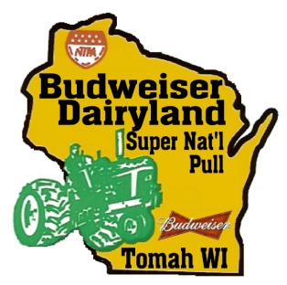
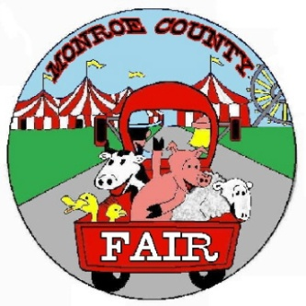
MONROE COUNTY AGRICULTURAL SOCIETY
P.O. BOX 908 – Tomah, WI 54660
Phone: 608-372-2081 Fax: 608-372-1052
Email: mail@tomahtractorpull.com
www.tomahtractorpull.com www.monroecountyfairwi.com

Promoter of the Monroe County Fair and the Budweiser Dairyland Super National Truck & Tractor Pull

June 20-22, 2024 July 24- 28, 2024

Monroe County Agricultural Society Scholarship Application

The Monroe County Agricultural Society (MCAS) would like to recognize our community’s outstanding leadership in young people and help students reach their academic goals.

Up to Four scholarships of $500.00 may be awarded.

Award selection is based on participation in a bona-fide youth organization approved by the MCAS board such as 4H, FFA, Boys & Girls Club along with community service activities and volunteer work within Monroe County.

To be eligible, scholarship applicants must have participated in 4H, FFA or any approved club/group. They must also meet the following criteria:

- Brookwood, Cashton, Tomah, Sparta School Districts.
- 4H, FFA, approved group/club member for 2 or more years.
- Plan to enroll in an accredited two- or four-year college or university.
- Applicants can presently be enrolled in a four-year college or a one-or two-year technical college.
- Cumulative high school or college grade point average between 2.50 and 4.00 (transcript required)
- Emphasis will be placed on community involvement experience and activities.

Applicant:

Name: ________________________________________ Parent(s): __________________________________

Address: _________________________________________________________________________________

Club Name: ______________________________________ Email: ___________________________________

Essay form please list the following on a separate sheet.
Career Goals: Work Experience: Volunteer Experience:

Applications will be accepted until March 15 they must be postmarked on or before March 15th.
Mail applications to Monroe County Ag Society, PO Box 908, Tomah, WI 54660
If awarded, a photo for follow-up publicity - Photos may be submitted to email: mail@tomahtractorpull.com

